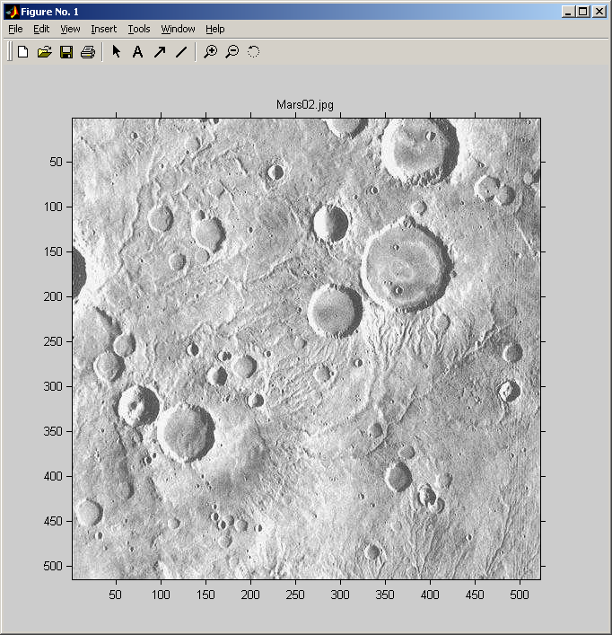
Original Image (Mars02)

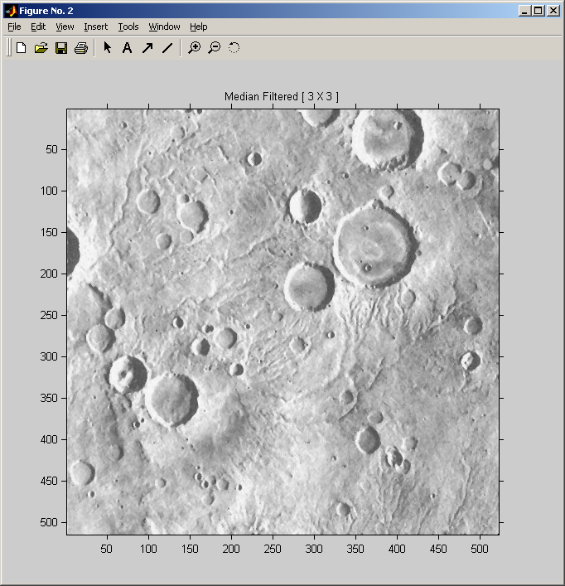
Median Filtered (3X3)

Method 1

Normalized Cross Correlation of a Crater Template Extracted from the Median Filtered Image

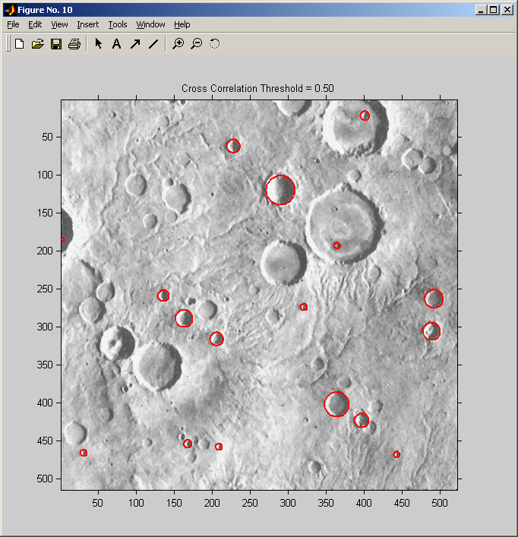
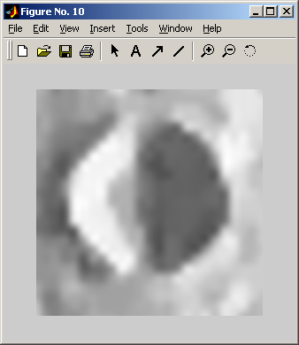
Template derived (user selected) from image

Small-medium craters found using normalized cross correlation of a single small crater.
Template is scaled across a range of radii.

Method 2

Directional Edge Operators,
Skeletonization,
Convolution with Circular Kernels
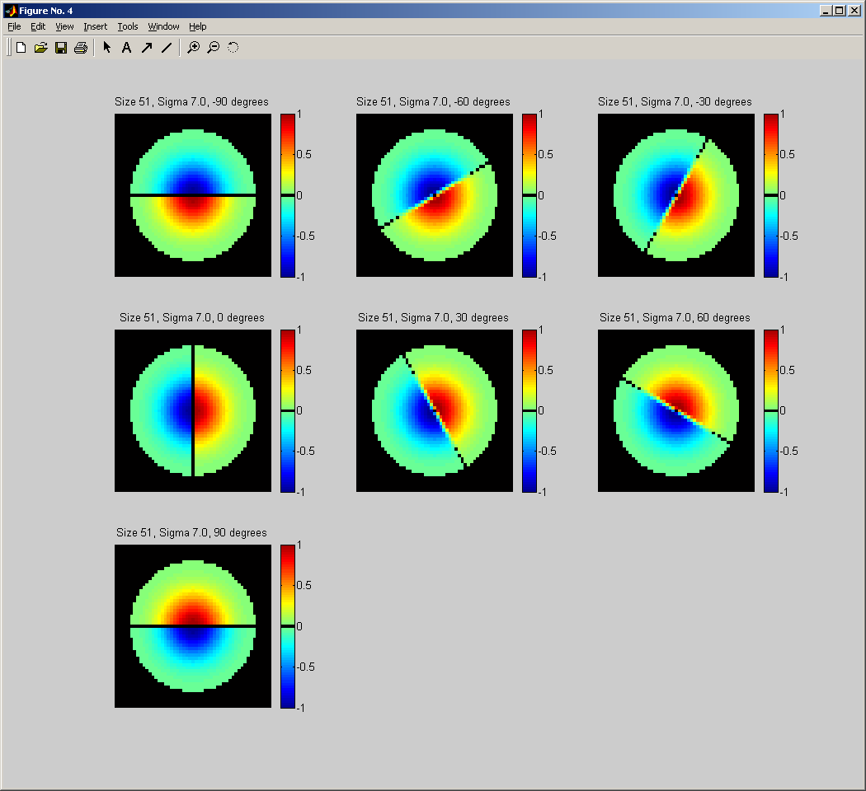

Gaussian directional edge operators are created to emphasize intensity transitions at the edges of craters.

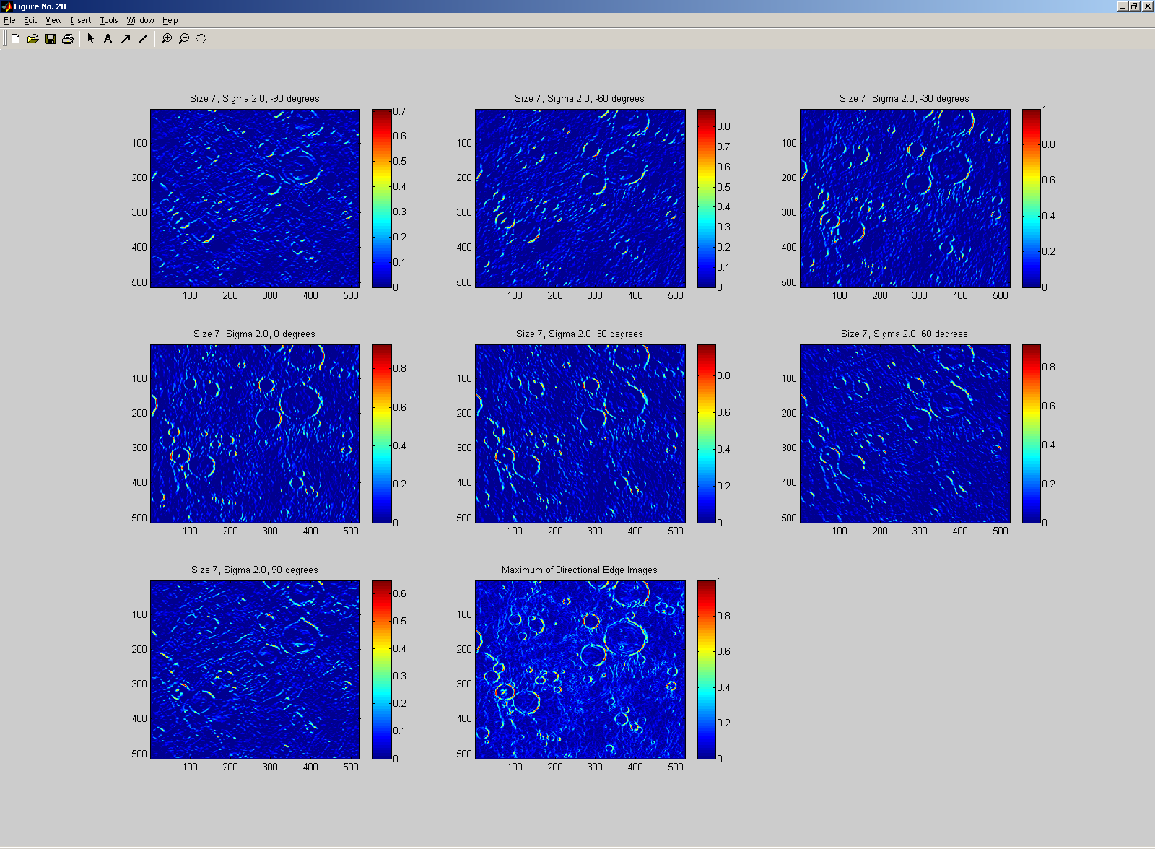

Application of the directional edge operators produces the above directional edge images. The red values in each image show the strongest edges in the direction associated with that directional edge image.

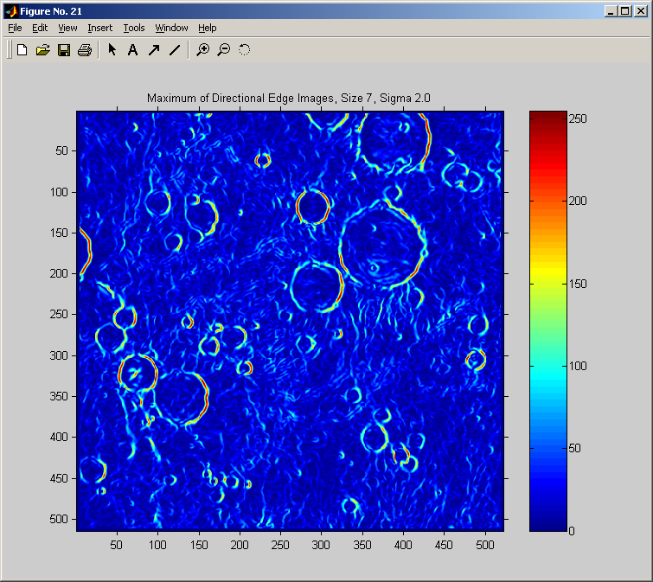
The above image shows the maximum edge values over all directional edge images (composite of all directions)

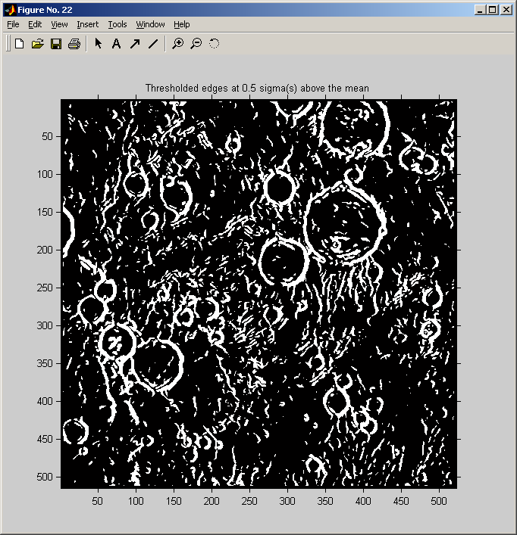

This is the result of thresholding the composite (maximum) directional edge image.

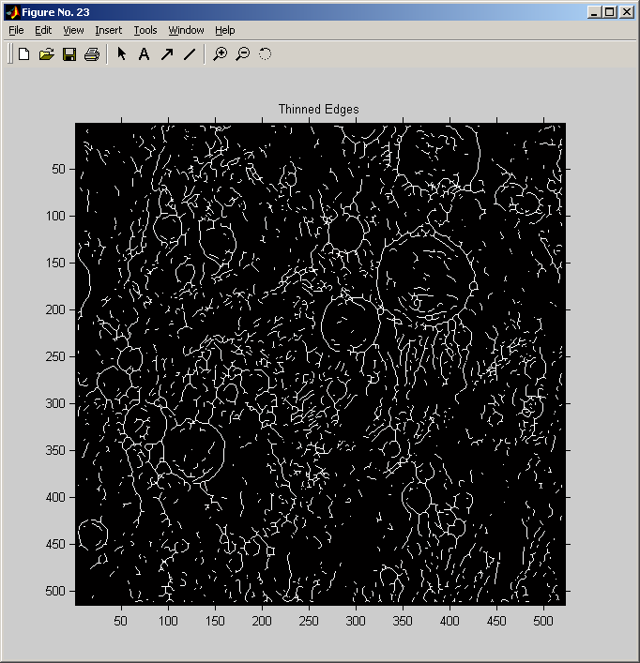
After skeletonizing (thinning) the thresholded image, the above is produced.

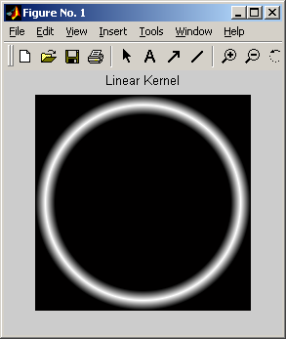
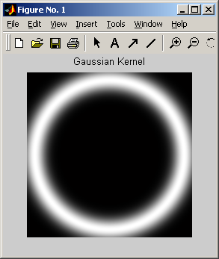
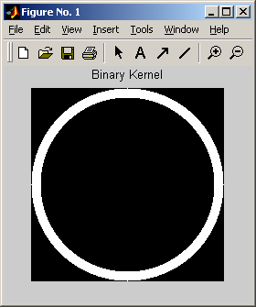

Binary Kernel Linear Kernel Gaussian Kernel

Circular Convolution kernels

In order to locate circular features in the skeletonized image, it is convolved with a circular kernel. Three circular kernels have been developed for this purpose. The first is a pure binary (0,1) kernel. The linear kernel has ones at the center of the ring and linearly decreases toward the edges of the ring. The gaussian kernel is one at the center of the ring and exponentially decreases (as a gaussian function) toward the edges. Thus far, the binary kernel seems to be the most useful.

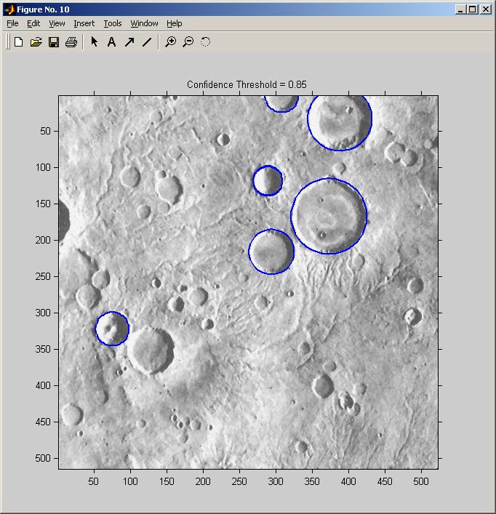

Circles found by thresholding the strongest convolutions of the binary kernel (with varying radii) with the skeletonized edge image. This approach has been useful for finding large craters.

Method 3

Convolution with an Annulus Kernel that Considers Direction of the Sun

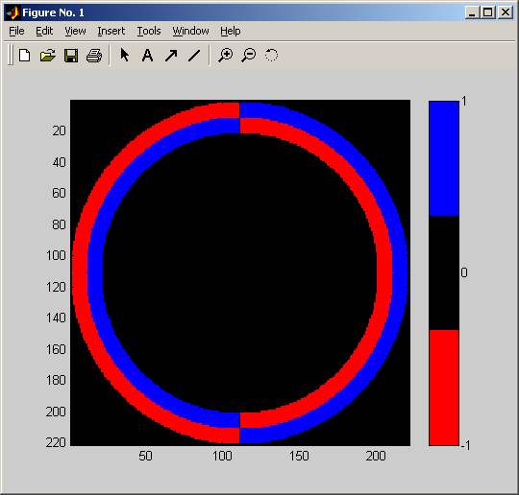
Annulus directional annulus kernel that emphasizes edges with the sun to the right.

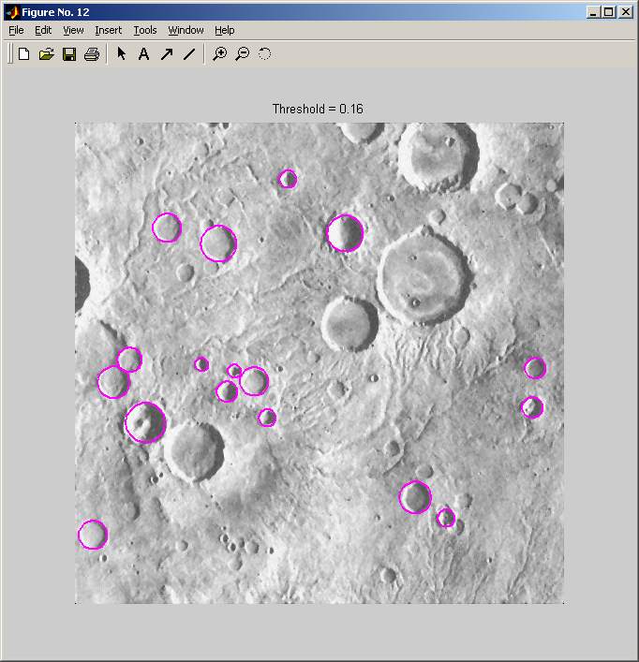
Craters found using the directional annulus kernel.

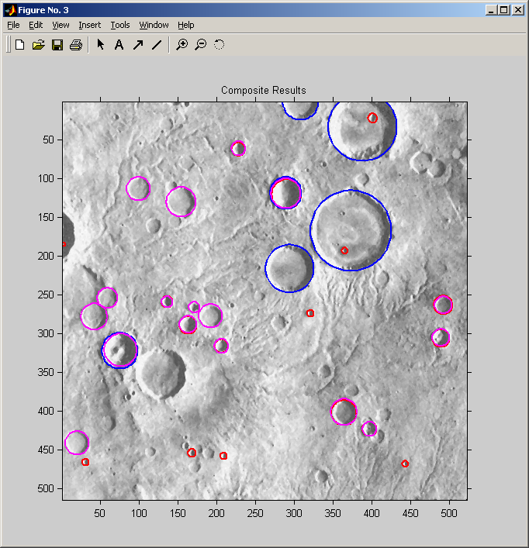

Composite of craters found using all three methods.
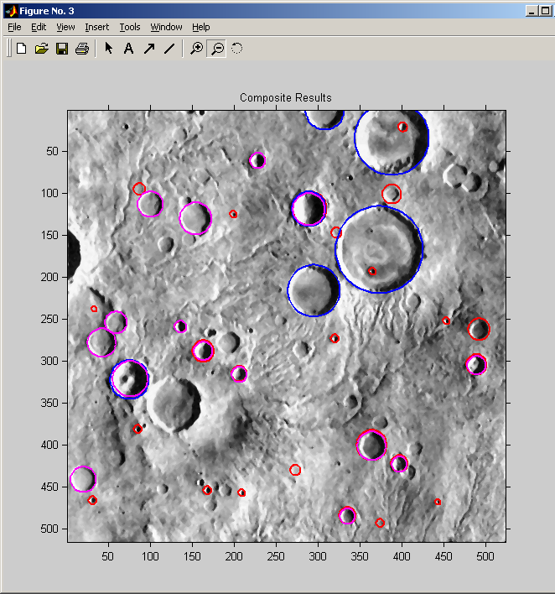
Results of same type of processing except that original image was contrast enhanced (m02_med3_bestFit80_1).

