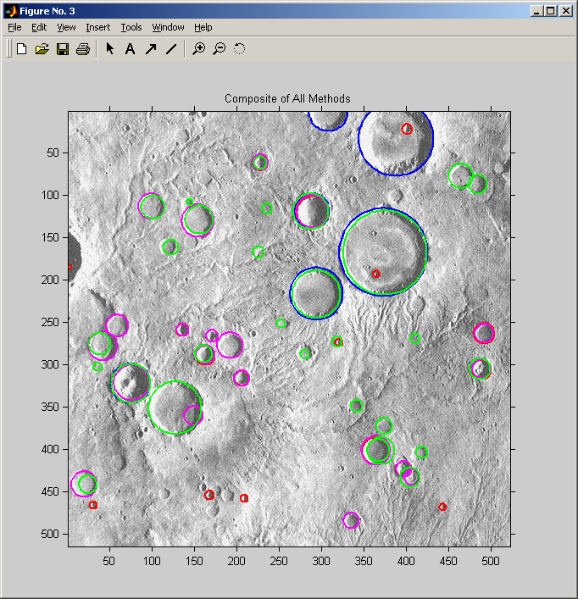

Found by using Hough transform accumulations

Found by cross-correlation of a single crater kernel template

Found using annulus crater convolution kernel (dependent on sun angle)

Found by convolving binary annulus with maxima of directional edges

