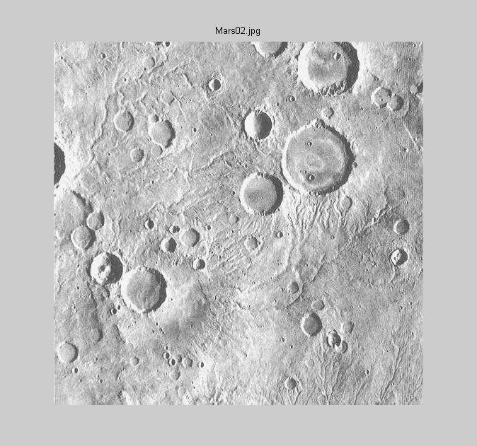

Original Image (Mars02)
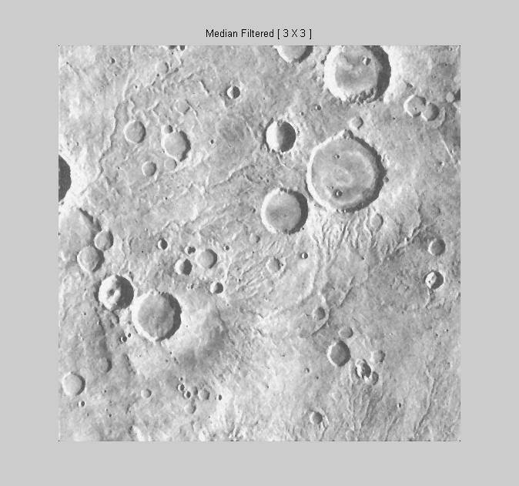

After applying 3X3 median filter
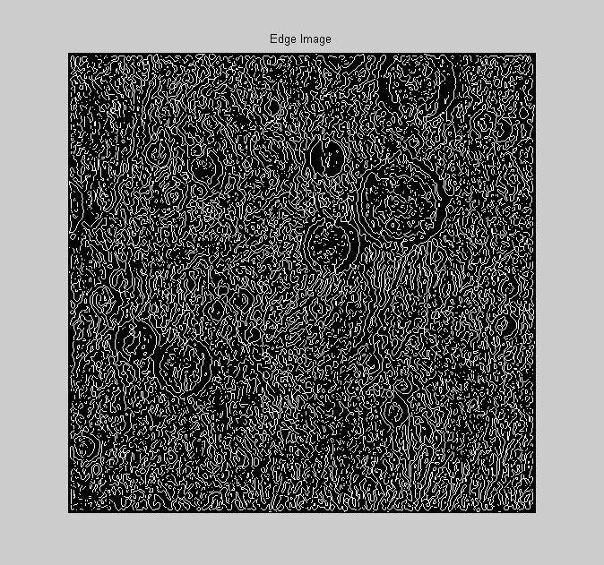

After applying a Laplacian-of-Gaussian (LOG) filter

The median filtered image is smoothed using a gaussian filter and a Laplacian operator is applied to the result. This emphasizes intensity changes, but without any directional information. The result of applying the LOG filter is then thresholded, producing the above result.
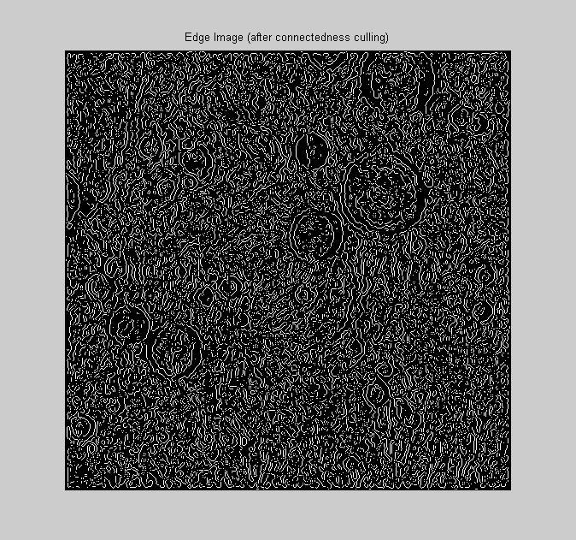

The thresholded LOG image contains many edges that merge at three or more points. The image above is the result of removing points that are common to three or more edges, thereby effectively disconnecting them. This step is performed in order to avoid attempting to process edges from different features (e.g. craters and valleys).
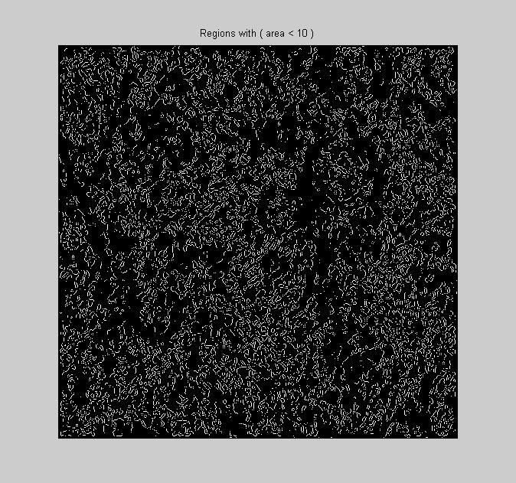

Edges with a small number of pixels (area) are removed. The above image shows the pixels that are removed.
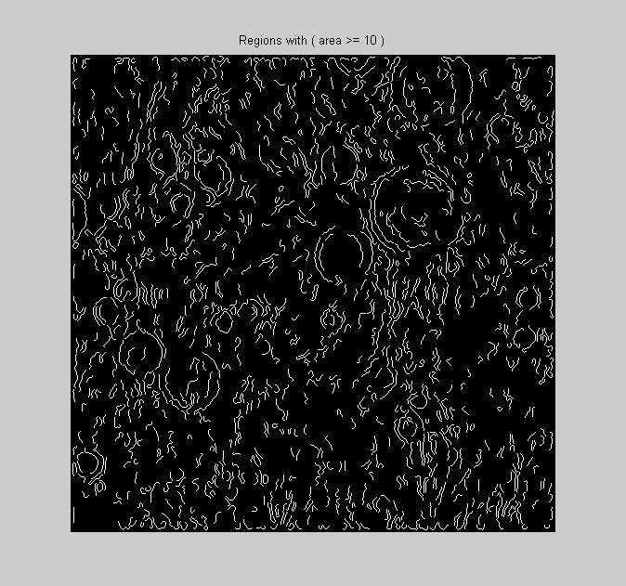

The above image contains edges with a large number (>= 10) of pixels.
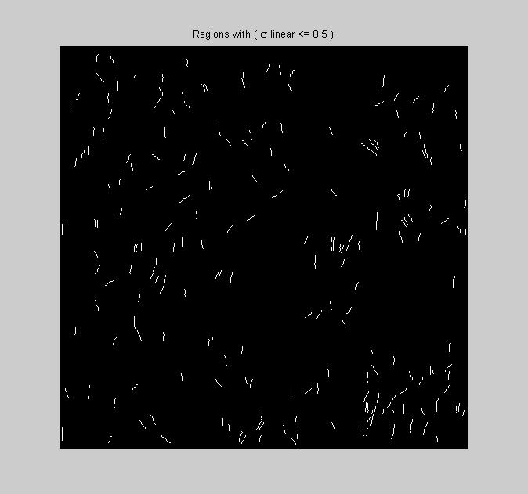

The edges that remain after area based culling are subjected to least squares line fitting. Those edges that tightly fit a line are removed. The above image shows which edges are removed based on this criterion.
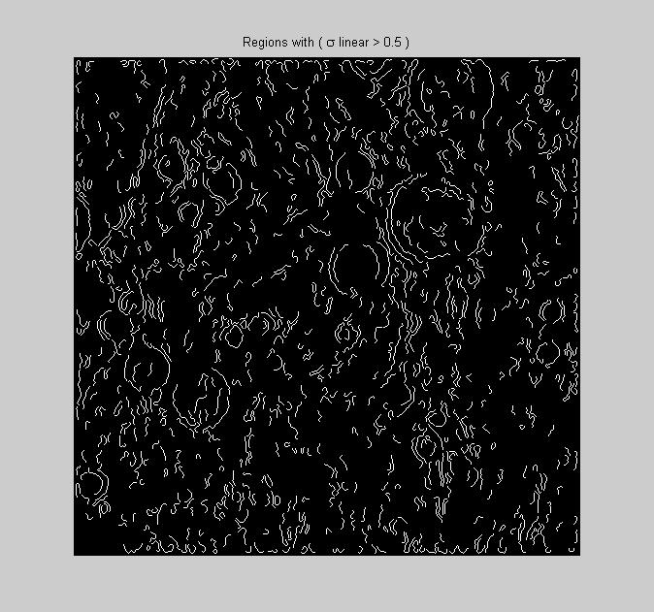

This image shows which edges remain after the linear fit criterion is applied.
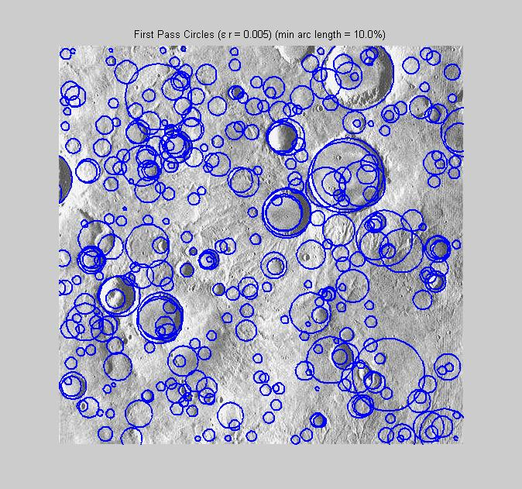

“First pass” circular arcs are fit to each of the edges that remain. The above image shows the complete circles that result from fitting the edges that survive the following criteria:

- The number of pixels in the arc must indicate that it subtends at least 10% of an entire circle.
- The variance from the center of the circle must not vary by more than 0.5% of the computed radius.
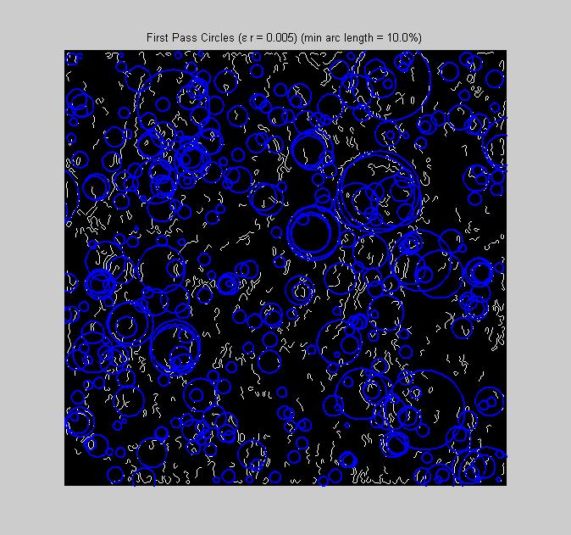

This image shows the locations of the first pass circles relative to the edges to which they were fit.
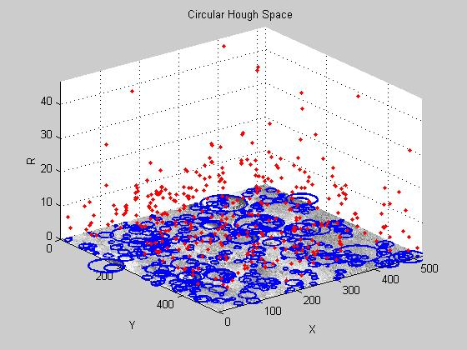

Some of the arcs that produced the first pass circles that were computed are actually the result of features from the same crater. For this reason, a Cartesian circular Hough space is constructed with the (x,y) and r axes representing the locations and radii of the centers of the previously computed circular arcs. In this space, each of the red points represents an (x,y,r) parameterization of an associated circular arc. Where these points cluster (are close together), there is evidence that arcs can be merged into a single (larger) arc.
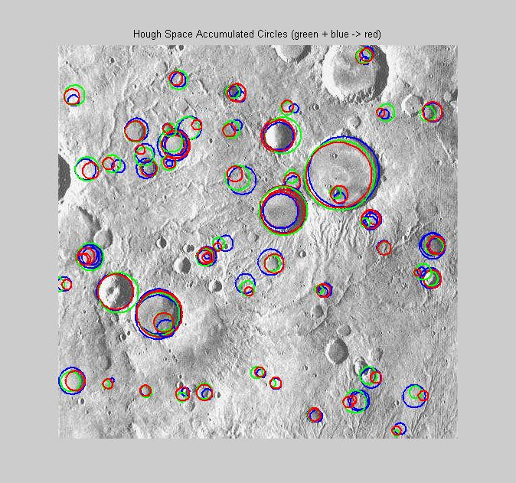

The above figure shows which arcs are merged as the result of clusters found in the Hough space. Smaller arcs that produce the circles (shown in green and blue) are merged into a larger arc whose associated circle is shown in red. The red circles are termed the “second pass” circles.
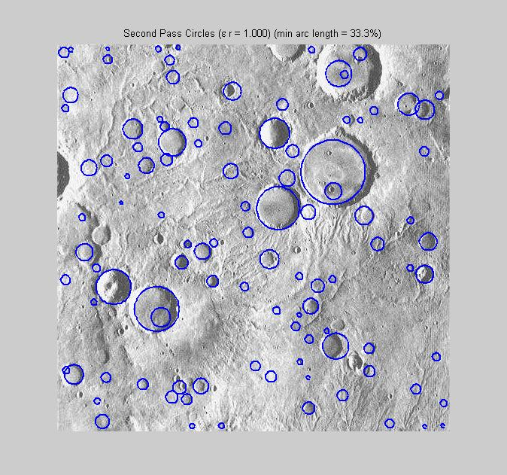

It should be the case that second pass circles are stronger than first pass circles, since more evidence (pixels) contributes to them. For this reason, the minimum acceptable arc length becomes 33.3%.

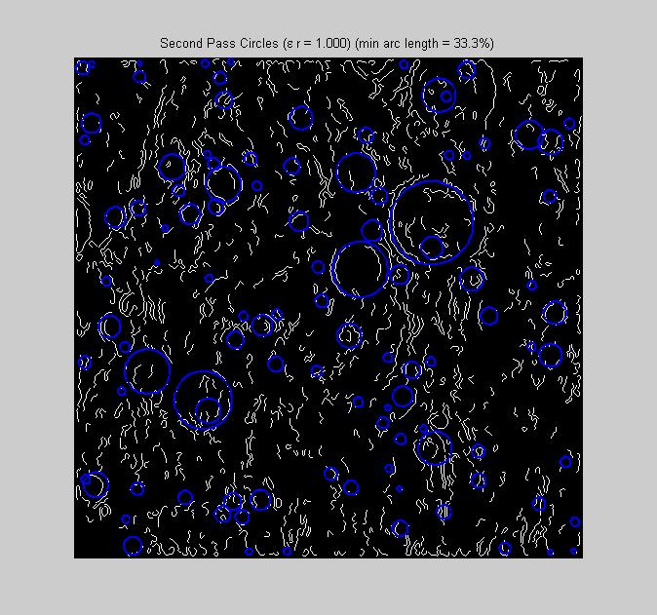

This image shows the second pass circles superimposed on the edge image used to compute circular arcs.

