Contrast Enhancement of Mars Images

The image contrast of craters and other terrain features varies due to several factors that include sun angle, surface reflectance, and perhaps the terrain itself. The performance of automated crater detection algorithms may be affected by image contrast. It is therefore desirable to provide some contrast enhancement to increase the consistency of images.

Four contrast enhancement methods were investigated. The methods implemented different local contrast enhancement approaches to accommodate the spatial variation of image contrast that may occur within an image. The image processing operations used in each method are summarized below. A 3x3 median filter providing noise reduction was the first operation used in each method and is therefore not listed below.

Method 1 - Redistribute pixel intensities to produce a uniform distribution (histogram equalization). Remove global shading; fit a 2nd order surface to the image, offset the surface to a zero mean and subtract the surface from image. Remove local shading; compute the mean intensity in a 48x48-pixel neighborhood and offset pixel intensities to a neighborhood mean of 128.

Method 2 - Find the minimum and maximum intensity in an 80x80-pixel neighborhood. Offset and scale pixel intensities so that minimum neighborhood intensity is black (0) and maximum neighborhood intensity is white (255).

Method 3 - Find the minimum and maximum intensity in a 32-pixel diameter neighborhood. Offset and scale pixel intensities so that minimum neighborhood intensity is black (0) and maximum neighborhood intensity is white (255). This method is similar to Method 2 but uses a smaller, circular neighborhood.

Method 4 - Compute the mean and standard deviation (sigma) of image intensity in an 80x80-pixel neighborhood. Offset and scale pixel intensities so that pixels 3 sigma (or greater) below the mean are black (0) and pixels 3 sigma (or greater) above the mean are white (255).

The four contrast enhancement methods were applied to a set of 20 images representing a variety of landforms and crater sizes. The variation of the image set is illustrated by the “Original Image” statistics in Table 1. The set of 20 images had an average intensity (132) near the middle of the 8-bit gray-scale (128)., There was, however, a lot variation among the image intensity means (sigma = 27) of the image set. Image contrast is characterized by the intensity standard deviation, which averaged 29 gray levels for the set of original images. There was also considerable contrast variation among the images (sigma = 8).

Results of the contrast enhancement methods are now discussed. All methods reduced the variation of mean image intensity among the images. Methods 1 and 2 were very effective at this (sigma = 1 and 2, respectively). Method 3 was least effective (sigma = 11), and in addition, shifted the mean intensity away from the gray-scale midpoint (mean = 155).

All contrast enhancement methods increased the intensity standard deviation (contrast), on average. All except Method 2 (sigma = 13) increased the consistency of the contrast statistic for the set of images. The high contrast produced by Methods 1 and 2 was generally excessive, and that produced by Method 3 was frequently excessive. Method 4 provided a 34% increase in contrast, on average, and a very consistent contrast statistic for the enhanced set of images. This is not surprising since Method 4 directly transformed the image intensity distribution to achieve a specified statistical fit.

Method 4 is expected to be the most appropriate of the contrast enhancement approaches investigated for image enhancement prior to crater detection. Alternate parameter values (neighborhood size, n_sigma) may yield improved performance. Image enhancement results provided by Method 4 are illustrated in Figure 1.

Table 1. Contrast Enhancement Statistics
 | Mean Image Intensity |  | Intensity Standard Deviation
 | Mean | Sigma | Mean | Sigma
Original Images | 132 | 27 | 29 | 8
Method 1 | 129 | 1 | 67 | 5
Method 2 | 131 | 9 | 66 | 13
Method 3 | 155 | 11 | 52 | 6
Method 4 | 128 | 2 | 39 | 1
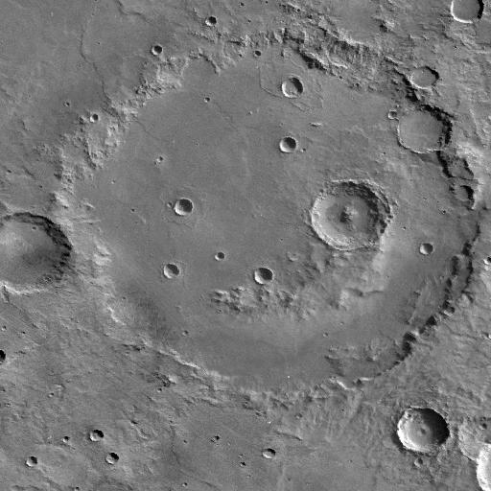
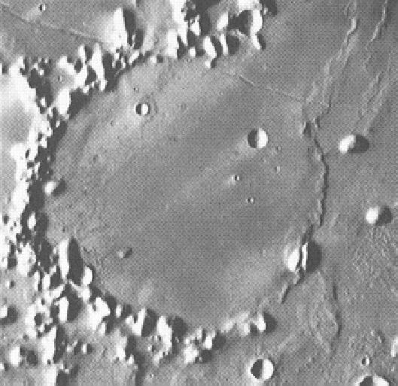
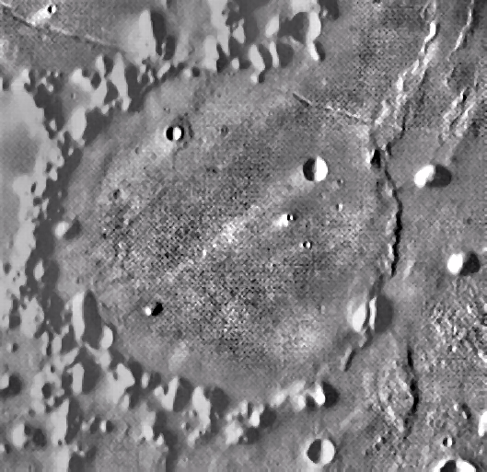
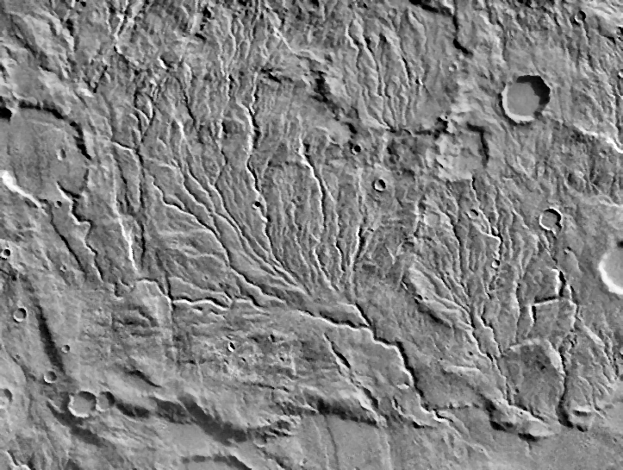
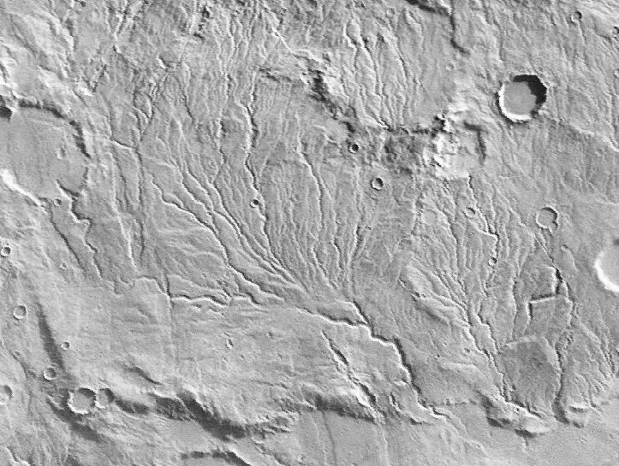
N = 20 images
Figure 1. Mars images before (left) and after contrast enhancement (right).

