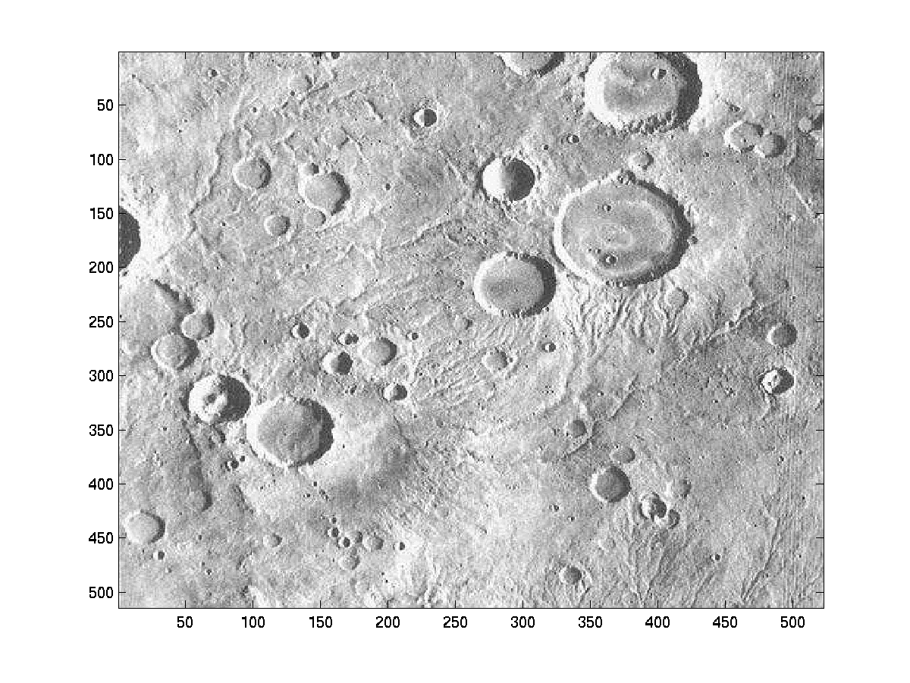
All craters below are expanded 3x...

Crater @ (254,251)
I think this might be a Medium crater, but the tool identifies it as Flat-Floored, with a fairly high degree of confidence. Now that I see the blow-up, it looks more Flat to me, too.

Crater @ (278,285)
I had this one labeled as Flat-Floored, but the tool thinks it is a Medium crater, though the confidence is right on the borderline. The tiny, overlapping crater at the 3 o'clock position shouldn't affect the results much, if at all.

Crater @ (334,483)
I catagorized this one as a Bowl, but the tool thinks it is a Medium. Parts of the crater match the pattern for flat, medium, and bowl, with the overall grade comfortably in the Medium range. From the blow-up, I'm starting to agree...

Crater @ (412,228)
I thought this one was a Medium, but the tool thinks it is Flat-Floored. Most of the crater matched the Flat pattern, but the overall result is close to the borderline. Again, from the blow-up, I could change my vote - it's looking pretty Flat.

Crater @ (483,87)
This crater overlaps the one above it and to the left. I thought it looked more like a Bowl, but the tool says Medium. I have another optimization to make in the AI code (to detect overlaps) that should shift the tool's result barely to Bowl, so this one might end up being correct.

